A
Project Report On

Project Name
STUDENT DATABASE

Prepared By:
<a href=”team member.docx”></a>

Guided By:

1. Mrs. RUPALI KUMARI
2. Mr. SACHIN KUMAR AGARWAL

-: ACKNOWLEDGEMENT:-
We would like to express our appreciation to the many people who have contributed to the successful completion of this Website. I am even so greteful to all this people for helping me to improve my understanding of numerous concepts in PHP and MYSQL.

We are thankful to respected for giving us opportunity to do this project. Their inspiration and generous support gave us sufficient strength to prepare the project.

We are also thankful to whom inspiration, guidance and generous support gave us sufficient strength to prepare the project. It is with profound feelings of gratitude we place on record our extreme indebiness to the and respected Mr. Sachin Kumar Agrawal and Mrs. Rupali Kumari for providing us technical input in the form of manuscripts, books and study materials and influencing our thinking.

Last but not least we would like to thank all those who have helped me directly or indirectly in develop in a successful project.

INDEX

- Abstract

- Application Flow

- Data Flow Diagram

- Objective & Scope Of Project

- Definition Of The Problem

- Details Of Hardware & Software

- Screen Shots

- Bibliography

-: ABSTRACT:-
We are make this project to help user friendly. In this project the on the Student Database. In the this project user can see the details of all about the Student details in the web site. Administrator can add the details of the students details in the web sites.

This project is very useful to the any type of student management & store the all types details on the web site without any paper work.

Help of this project any one can access the details of the students & if any one want to know about the courses of this student than they are see without visiting the collage & without wating the their time.

If any one use want to give sugession about the student or the project than user give their details using feedback form.

If any one user want to contact to the administrator or manager of the student or get the details of the contect number & addresses know in the contecct us page & user can contect the administrator using this page.

Application flow

Homepage

Homepage
Result Database
Team
Members
Contact us

Homepage

Show Database
Result Database
Contact
Details
Team

DATA FLOW DIAGARAM

LOGIN CHECK
CLIENT

Home Page

Admission
Standard
Staff

ADMINISTRATOR

LOGIN CHECK
CLIENT

Home Page

Admission
Standard
Staff

ADMINISTRATOR

GRADE

SUBJECTCODE
SUBJECT NAME
CREDIT

STUDENT

OBJECTIVE & SCOPE OF PROJECT

As students of B.TECH Field, We try our best to cover all requirements which are used to complete where web application.

We have tried to prepare the project on Student Database objects of our project are:

DEFINITION OF THE PROBLEM

System is for the computerized used for the Website . Now a days in area of a computer we see each and every find is being coputerized so, giving automatic and safe way of GPA Calculate and speedly way is a good move for any Calculations.

This project is executive developed for any Grade Point Average Calculations, can satisfied their customer requirement administrate they give manual ”invoice” gives the date for previous record and the area in which they are given services.

SYSTEM ANALYSIS

DETAILS OF HARDWARE & SOFTWARE

- Web Server :- Xampp [v3.2.4]
- Web Browser :- Chrome
- Technology :- PHP 4, PHP 5
- Database Server :- My SQL [ 5.0.21]
- Webpage Tools :-HTML,CSS,BOOTSTRAP

Software specification:-

- PHP:
PHP is the large no of internet service providers (ISPs) and web hosting companies that support it. Today there are hundreds of thousands of developers using PHP, and it’s not surprising that there are so many, considering that several thet several million sites are reported to have php installed.

PHP is a cross platform technology and that once you’ve wrriten your web page, it’s easy to get it up and running on our web server but how does php compare with other technologies out there? Well, comparing php with perl is a bit tricky becouse they were designed for different things.

PHP was specifically designed to rapidly create dynamic web content; perl was not. As a result, perl can sometimes be a complicated language that can become prohibitive for users who want to create web pages. Comparing php with asp is a more balanced comparison, but then you have to pay for asp, and asp doesn’t work well on a variety of platforms it needs to be used on other proprietary for which you also must pay.

- MYSQL:
MYSQL is a freely available RDBMS. Which fully joined the open source community only recentli, when it was released under the GNU public license(GPL). Even before it want free, you didn’t need a license unless you wanted to make money out of it, or run the server on the windows platform.(the windows version of mysql was shareware). Because you now don’t have to pay a dime to use it, this alone makes mysql a solidcandidate for developing application. If the GPL worries you for any reason, or you need to incorporate mysql into a commercial application, you can still buy a commercially licensed version from the developers at www.mysql.com.

3. BOOTSTRAP : Bootstrap is a free and open-source CSS framework directed at responsive, mobile-first front-end web development. It contains CSS- and (optionally) JavaScript-based design templates for typography, forms, buttons, navigation and other interface components.
Bootstrap is the third-most-starred project on GitHub, with more than 135,000 stars, behind only freeCodeCamp (almost 305,000 stars) and marginally behind Vue.js framework.^{[2]} According to Alexa Rank, Bootstrap getbootstrap.com is in the top-2000 in US while vuejs.org is in top-7000 in US.^{[3]}
4. HTML: Hypertext Markup Language (HTML) is the standard markup language for documents designed to be displayed in a web browser. It can be assisted by technologies such as Cascading Style Sheets (CSS) and scripting languages such as JavaScript.
Web browsers receive HTML documents from a web server or from local storage and render the documents into multimedia web pages. HTML describes the structure of a web page semantically and originally included cues for the appearance of the document.
5. CSS: Cascading Style Sheets (CSS) is a style sheet language used for describing the presentation of a document written in a markup language like HTML.^{[1]} CSS is a cornerstone technology of the World Wide Web, alongside HTML and JavaScript.^{[2]}
CSS is designed to enable the separation of presentation and content, including layout, colors, and fonts.^{[3]} This separation can improve content accessibility, provide more flexibility and control in the specification of presentation characteristics, enable multiple web pages to share formatting by specifying the relevant CSS in a separate .css file, and reduce complexity and repetition in the structural content.

A COMPLETE ANALYSIS &
DESIGN DOCUMENT



RESULT DATA

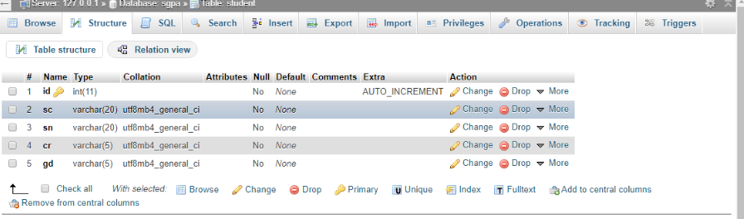

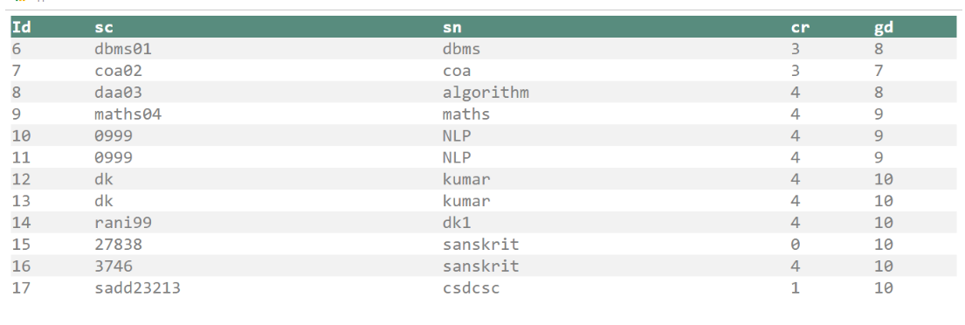

STANDARD TABLE

Validation
1. User must be filling up the all fields.
2. User can not enter character value in numeric fields.
3. User can not enter numeric value in character fields.

Homepage

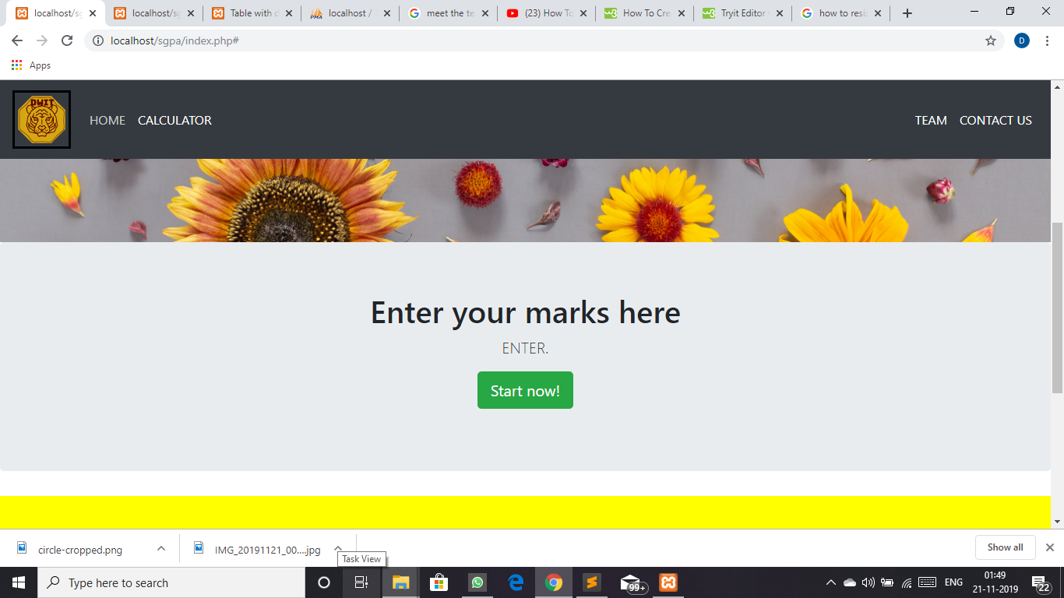

RESULT DATABASE

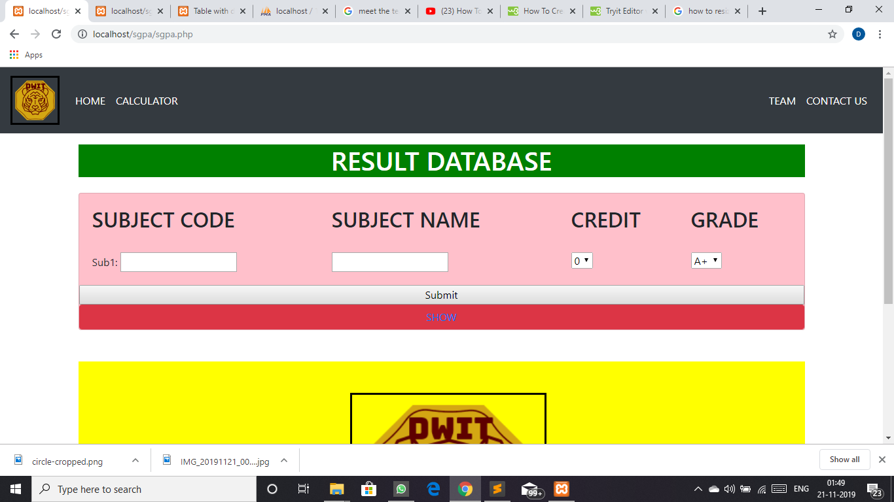

TEAM MEMBERS

